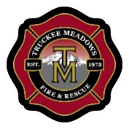
Automatic Aid Analysis
April 6, 2021

Priority One and Two EMS Incidents

July 1, 2018 to June 30, 2020

Results | # Calls
In Reno Fire and closest to Reno Fire | 50759
In Reno Fire and closest to Sparks Fire | 524
In Reno Fire and closest to TMFPD | 4264
In TMFPD and closest to NLTFPD | 16
In TMFPD and closest to Reno Fire | 2115
In TMFPD and closest to Sparks Fire | 518
In TMFPD and closest to TMFPD | 9872
Grand Total | 68068

